- Prepare an individual report demonstrating that you a) understand the key ideas presented in the assigned readings for Week 1 and b) can analyze critically the extent to which they are applicable in your current workplace. Your report should be 800-1000 words and must cite supporting evidence from the readings. Your report should be double-spaced and use APA format. The title page, reference list, and any appendices are not included in this suggested word count. You do not need to include an abstract.
- The questions your report must address are: What business model does your company use? What is your organization’s vision and mission? What objective evidence is there that your organization's vision, mission, and objectives is helping it gain a sustainable competitive advantage? Only briefly touch on what objective evidence, using the Three Tests of a Winning Strategy, is there that your organization’s vision, mission, and objectives support its strategy? (We will address the three tests in more detail later) Be sure to introduce your argument, explain your understanding of key terms, present your reasoning, and include independently verifiable supporting evidence.
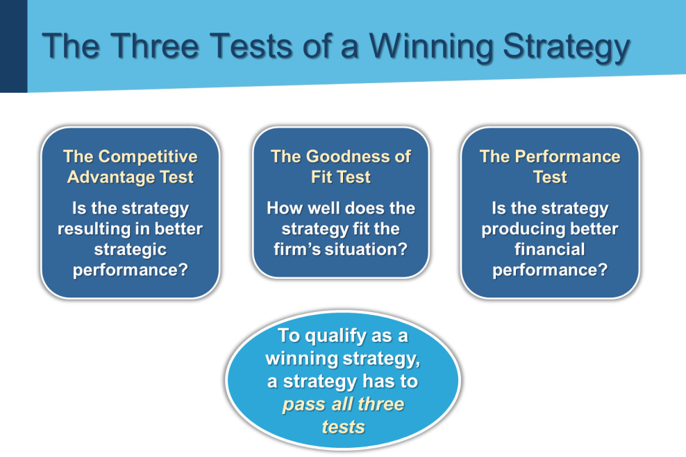

Required Readings:
Barnat, R. (n.d.). Strategic goals and objectives. In Strategic management: formulation and implementation. Retrieved from http://www.strategy-formulation.24xls.com/en210
Barnat, R. (n.d.). Tests of a winning strategy. In Strategic management: formulation and implementation. Retrieved from http://www.strategy-formulation.24xls.com/en317
Defining strategic management and strategy. (2012). In Mastering strategic management. Washington, DC: Saylor Academy. Retrieved from https://saylordotorg.github.io/text_mastering-strategic-management/s05-01-defining-strategic-management-.html
Understanding the strategic management process. (2012). In Mastering strategic management. Washington, DC: Saylor Academy. Retrieved from https://saylordotorg.github.io/text_mastering-strategic-management/s05-04-understanding-the-strategic-ma.html
Vision, mission, and goals. (2012). In Mastering strategic management. Washington, DC: Saylor Academy. Retrieved from https://saylordotorg.github.io/text_mastering-strategic-management/s06-01-vision-mission-and-goals.html
Watkins, M. D. (2007, September 7). Demystifying strategy: the what, who, how, and why. Harvard Business Review. Retrieved from https://hbr.org/2007/09/demystifying-strategy-the-what/

